Versioned Archive and Review of Biotic Interactions and Taxon Names Found within globalbioticinteractions/limbu2025 hash://md5/cdc6545ee343cc33587ef7b51f265da5
by Nomer, Elton and Preston, three naive review bots
review@globalbioticinteractions.org
https://globalbioticinteractions.org/contribute
https://github.com/globalbioticinteractions/limbu2025/issues
2026-03-31
Abstract
Life on Earth is sustained by complex interactions between organisms and their environment. These biotic interactions can be captured in datasets and published digitally. We present a review and archiving process for such an openly accessible digital interactions dataset of known origin and discuss its outcome. The dataset under review, named globalbioticinteractions/limbu2025, has fingerprint hash://md5/cdc6545ee343cc33587ef7b51f265da5, is 12.6MiB in size and contains 37,571 interactions with 2 unique types of associations (e.g., coOccursWith) between 281 primary taxa (e.g., Entrophospora lamellosum) and 2,008 associated taxa (e.g., Zea mays). This report includes detailed summaries of interaction data, a taxonomic review from multiple catalogs, and an archived version of the dataset from which the reviews are derived.
Table of Contents

Introduction

Data Review and Archive
Data review and archiving can be a time-consuming process, especially when done manually. This review report aims to help facilitate both activities. It automates the archiving of datasets, including Darwin Core archives, and is a citable backup of a version of the dataset. Additionally, an automatic review of species interaction claims made in the dataset is generated and registered with Global Biotic Interactions (J. H. Poelen, Simons, and Mungall 2014).
This review includes summary statistics about, and observations about, the dataset under review :
S. Pehim Limbu, S.L. Stürmer, G. Zahn, C.A. Aguilar-Trigueros, N. Rogers, & V.B. Chaudhary, Climate-linked biogeography of mycorrhizal fungal spore traits, Proc. Natl. Acad. Sci. U.S.A. 122 (29) e2505059122, https://doi.org/10.1073/pnas.2505059122 (2025). https://github.com/globalbioticinteractions/limbu2025/archive/461a5f43a0ceadec056ca19816e9209ea8b317b1.zip 2026-03-28T03:08:20.405Z hash://md5/cdc6545ee343cc33587ef7b51f265da5
For additional metadata related to this dataset, please visit https://github.com/globalbioticinteractions/limbu2025 and inspect associated metadata files including, but not limited to, README.md, eml.xml, and/or globi.json.

Methods
The review is performed through programmatic scripts that leverage tools like Preston (Elliott et al. 2025), Elton (Kuhn, Poelen, and Leinweber 2025), Nomer (Salim and Poelen 2025), globinizer (J. Poelen, Seltmann, and Mietchen 2024) combined with third-party tools like grep, mlr, tail and head.
Tools used in this review process
tool name | version
preston | 0.11.1
elton | 0.16.7
nomer | 0.6.2
globinizer | 0.4.0
mlr | 6.0.0
jq | 1.6
yq | 4.25.3
pandoc | 3.1.6.1
duckdb | 1.3.1
mapserver | 7.6.4
The review process can be described in the form of the script below .
# get versioned copy of the dataset (size approx. 12.6MiB) under review
elton pull globalbioticinteractions/limbu2025
# generate review notes
elton review globalbioticinteractions/limbu2025\
> review.tsv
# export indexed interaction records
elton interactions globalbioticinteractions/limbu2025\
> interactions.tsv
# export names and align them with the Catalogue of Life using Nomer
elton names globalbioticinteractions/limbu2025\
| nomer append col\
> name-alignment.tsv
or visually, in a process diagram.
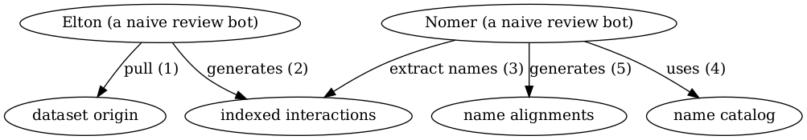
Review Process Overview
You can find a copy of the full review script at check-data.sh. See also GitHub and Codeberg.

Results
In the following sections, the results of the review are summarized . Then, links to the detailed review reports are provided.

Files
The following files are produced in this review:
filename | description
biblio.bib | list of bibliographic reference of this review
check-dataset.sh | data review workflow/process as expressed in a bash script
data.zip | a versioned archive of the data under review
HEAD | the digital signature of the data under review
index.docx | review in MS Word format
index.html | review in HTML format
index.md | review in Pandoc markdown format
index.pdf | review in PDF format
indexed-citations.csv.gz | list of distinct reference citations for reviewed species interaction claims in gzipped comma-separated values file format
indexed-citations.html.gz | list of distinct reference citations for reviewed species interactions claims in gzipped html file format
indexed-citations.tsv.gz | list of distinct reference citations for reviewed species interaction claims in gzipped tab-separated values format
indexed-interactions-col-family-col-family.svg | network diagram showing the taxon family to taxon family interaction claims in the dataset under review as interpreted by the Catalogue of Life via Nomer Corpus of Taxonomic Resources (J. H. (ed. ). Poelen 2024)
indexed-interactions-col-kingdom-col-kingdom.svg | network diagram showing the taxon kingdom to taxon kingom interaction claims in the dataset under review as interpreted by the Catalogue of Life via Nomer Corpus of Taxonomic Resources (J. H. (ed. ). Poelen 2024)
indexed-interactions.csv.gz | species interaction claims indexed from the dataset under review in gzipped comma-separated values format
indexed-interactions.html.gz | species interaction claims indexed from the dataset under review in gzipped html format
indexed-interactions.tsv.gz | species interaction claims indexed from the dataset under review in gzipped tab-separated values format
indexed-interactions.parquet | species interaction claims indexed from the dataset under review in Apache Parquet format
indexed-interactions.png | species interaction claims indexed from the dataset under review plotted on a map
indexed-interactions.map | mapserver configuration to plot species interaction claims indexed from the dataset under review on a map
indexed-interactions.gpkg | species interaction claims indexed from the dataset under review in GeoPackage format
indexed-interactions-h3.gpkg | geospatially clustered h3 species interaction claims indexed from the dataset under review in GeoPackage format
indexed-interactions-sample.csv | list of species interaction claims indexed from the dataset under review in gzipped comma-separated values format
indexed-interactions-sample.html | first 500 species interaction claims indexed from the dataset under review in html format
indexed-interactions-sample.tsv | first 500 species interaction claims indexed from the dataset under review in tab-separated values format
indexed-names.csv.gz | taxonomic names indexed from the dataset under review in gzipped comma-separated values format
indexed-names.html.gz | taxonomic names found in the dataset under review in gzipped html format
indexed-names.tsv.gz | taxonomic names found in the dataset under review in gzipped tab-separated values format
indexed-names.parquet | taxonomic names found in the dataset under review in Apache Parquet format
indexed-names-resolved-col.csv.gz | taxonomic names found in the dataset under review aligned with the Catalogue of Life as accessed through the Nomer Corpus of Taxonomic Resources (J. H. (ed. ). Poelen 2024) in gzipped comma-separated values format
indexed-names-resolved-col.html.gz | taxonomic names found in the dataset under review aligned with the Catalogue of Life as accessed through the Nomer Corpus of Taxonomic Resources (J. H. (ed. ). Poelen 2024) in gzipped html format
indexed-names-resolved-col.tsv.gz | taxonomic names found in the dataset under review aligned with the Catalogue of Life as accessed through the Nomer Corpus of Taxonomic Resources (J. H. (ed. ). Poelen 2024) in gzipped tab-separated values format
indexed-names-resolved-col.parquet | taxonomic names found in the dataset under review aligned with the Catalogue of Life as accessed through the Nomer Corpus of Taxonomic Resources (J. H. (ed. ). Poelen 2024) in Apache Parquet format
indexed-names-resolved-discoverlife.csv.gz | taxonomic names found in the dataset under review aligned with Discover Life bee species checklist as accessed through the Nomer Corpus of Taxonomic Resources (J. H. (ed. ). Poelen 2024) in gzipped comma-separated values format
indexed-names-resolved-discoverlife.html.gz | taxonomic names found in the dataset under review aligned with Discover Life bee species checklist as accessed through the Nomer Corpus of Taxonomic Resources (J. H. (ed. ). Poelen 2024) in gzipped html format
indexed-names-resolved-discoverlife.tsv.gz | taxonomic names found in the dataset under review aligned with Discover Life bee species checklist as accessed through the Nomer Corpus of Taxonomic Resources (J. H. (ed. ). Poelen 2024) in gzipped tab-separated values format
indexed-names-resolved-discoverlife.parquet | taxonomic names found in the dataset under review aligned with Discover Life bee species checklist as accessed through the Nomer Corpus of Taxonomic Resources (J. H. (ed. ). Poelen 2024) in Apache Parquet format
indexed-names-resolved-gbif.csv.gz | taxonomic names found in the dataset under review aligned with GBIF Backbone Taxonomy as accessed through the Nomer Corpus of Taxonomic Resources (J. H. (ed. ). Poelen 2024) in gzipped comma-separated values format
indexed-names-resolved-gbif.html.gz | taxonomic names found in the dataset under review aligned with GBIF Backbone Taxonomy as accessed through the Nomer Corpus of Taxonomic Resources (J. H. (ed. ). Poelen 2024) in gzipped html format
indexed-names-resolved-gbif.tsv.gz | taxonomic names found in the dataset under review aligned with GBIF Backbone Taxonomy as accessed through the Nomer Corpus of Taxonomic Resources (J. H. (ed. ). Poelen 2024) in gzipped tab-separated values format
indexed-names-resolved-gbif.parquet | taxonomic names found in the dataset under review aligned with GBIF Backbone Taxonomy as accessed through the Nomer Corpus of Taxonomic Resources (J. H. (ed. ). Poelen 2024) in Apache Parquet format
indexed-names-resolved-itis.csv.gz | taxonomic names found in the dataset under review aligned with Integrated Taxonomic Information System (ITIS) as accessed through the Nomer Corpus of Taxonomic Resources (J. H. (ed. ). Poelen 2024) in gzipped comma-separated values format
indexed-names-resolved-itis.html.gz | taxonomic names found in the dataset under review aligned with Integrated Taxonomic Information System (ITIS) as accessed through the Nomer Corpus of Taxonomic Resources (J. H. (ed. ). Poelen 2024) in gzipped html format
indexed-names-resolved-itis.tsv.gz | taxonomic names found in the dataset under review aligned with Integrated Taxonomic Information System (ITIS) as accessed through the Nomer Corpus of Taxonomic Resources (J. H. (ed. ). Poelen 2024) in gzipped tab-separated values format
indexed-names-resolved-itis.parquet | taxonomic names found in the dataset under review aligned with Integrated Taxonomic Information System (ITIS) as accessed through the Nomer Corpus of Taxonomic Resources (J. H. (ed. ). Poelen 2024) in Apache Parquet format
indexed-names-resolved-mdd.csv.gz | taxonomic names found in the dataset under review aligned with the Mammal Diversity Database as accessed through the Nomer Corpus of Taxonomic Resources (J. H. (ed. ). Poelen 2024) in gzipped comma-separated values format
indexed-names-resolved-mdd.html.gz | taxonomic names found in the dataset under review aligned with Mammal Diversity Database as accessed through the Nomer Corpus of Taxonomic Resources (J. H. (ed. ). Poelen 2024) in gzipped html format
indexed-names-resolved-mdd.tsv.gz | taxonomic names found in the dataset under review aligned with Mammal Diversity Database as accessed through the Nomer Corpus of Taxonomic Resources (J. H. (ed. ). Poelen 2024) in gzipped tab-separated values format
indexed-names-resolved-mdd.parquet | taxonomic names found in the dataset under review aligned with Mammal Diversity Database as accessed through the Nomer Corpus of Taxonomic Resources (J. H. (ed. ). Poelen 2024) in Apache Parquet format
indexed-names-resolved-ncbi.csv.gz | taxonomic names found in the dataset under review aligned with the NCBI Taxonomy as accessed through the Nomer Corpus of Taxonomic Resources (J. H. (ed. ). Poelen 2024) in gzipped comma-separated values format
indexed-names-resolved-ncbi.html.gz | taxonomic names found in the dataset under review aligned with the NCBI Taxonomy as accessed through the Nomer Corpus of Taxonomic Resources (J. H. (ed. ). Poelen 2024) in gzipped html format
indexed-names-resolved-ncbi.tsv.gz | taxonomic names found in the dataset under review aligned with the NCBI Taxonomy as accessed through the Nomer Corpus of Taxonomic Resources (J. H. (ed. ). Poelen 2024) in gzipped tab-separated values format
indexed-names-resolved-ncbi.parquet | taxonomic names found in the dataset under review aligned with the NCBI Taxonomy as accessed through the Nomer Corpus of Taxonomic Resources (J. H. (ed. ). Poelen 2024) in Apache Parquet format
indexed-names-resolved-pbdb.csv.gz | taxonomic names found in the dataset under review aligned with the Paleobiology Database as accessed through the Nomer Corpus of Taxonomic Resources (J. H. (ed. ). Poelen 2024) in gzipped comma-separated values format
indexed-names-resolved-pbdb.html.gz | taxonomic names found in the dataset under review aligned with Paleobiology Database as accessed through the Nomer Corpus of Taxonomic Resources (J. H. (ed. ). Poelen 2024) in gzipped html format
indexed-names-resolved-pbdb.tsv.gz | taxonomic names found in the dataset under review aligned with Paleobiology Database as accessed through the Nomer Corpus of Taxonomic Resources (J. H. (ed. ). Poelen 2024) in gzipped tab-separated values format
indexed-names-resolved-pbdb.parquet | taxonomic names found in the dataset under review aligned with Paleobiology Database as accessed through the Nomer Corpus of Taxonomic Resources (J. H. (ed. ). Poelen 2024) in Apache Parquet format
indexed-names-resolved-tpt.csv.gz | taxonomic names found in the dataset under review aligned with the Terrestrial Parasite Tracker (TPT) Taxonomic Resource as accessed through the Nomer Corpus of Taxonomic Resources (J. H. (ed. ). Poelen 2024) in gzipped comma-separated values format
indexed-names-resolved-tpt.html.gz | taxonomic names found in the dataset under review aligned with the Terrestrial Parasite Tracker (TPT) Taxonomic Resource as accessed through the Nomer Corpus of Taxonomic Resources (J. H. (ed. ). Poelen 2024) in gzipped html format
indexed-names-resolved-tpt.tsv.gz | taxonomic names found in the dataset under review aligned with the Terrestrial Parasite Tracker (TPT) Taxonomic Resource as accessed through the Nomer Corpus of Taxonomic Resources (J. H. (ed. ). Poelen 2024) in gzipped tab-separated values format
indexed-names-resolved-tpt.parquet | taxonomic names found in the dataset under review aligned with the Terrestrial Parasite Tracker (TPT) Taxonomic Resource as accessed through the Nomer Corpus of Taxonomic Resources (J. H. (ed. ). Poelen 2024) in Apache Parquet format
indexed-names-resolved-wfo.csv.gz | taxonomic names found in the dataset under review aligned with the World of Flora Online as accessed through the Nomer Corpus of Taxonomic Resources (J. H. (ed. ). Poelen 2024) in gzipped comma-separated values format
indexed-names-resolved-wfo.html.gz | taxonomic names found in the dataset under review aligned with the World of Flora Online as accessed through the Nomer Corpus of Taxonomic Resources (J. H. (ed. ). Poelen 2024) in gzipped html format
indexed-names-resolved-wfo.tsv.gz | taxonomic names found in the dataset under review aligned with the World of Flora Online as accessed through the Nomer Corpus of Taxonomic Resources (J. H. (ed. ). Poelen 2024) in gzipped tab-separated values format
indexed-names-resolved-wfo.parquet | taxonomic names found in the dataset under review aligned with the World of Flora Online as accessed through the Nomer Corpus of Taxonomic Resources (J. H. (ed. ). Poelen 2024) in Apache Parquet format
indexed-names-resolved-worms.csv.gz | taxonomic names found in the dataset under review aligned with the World Register of Marine Species (WoRMS) as accessed through the Nomer Corpus of Taxonomic Resources (J. H. (ed. ). Poelen 2024) in gzipped comma-separated values format
indexed-names-resolved-worms.html.gz | taxonomic names found in the dataset under review aligned with the World Register of Marine Species (WoRMS) as accessed through the Nomer Corpus of Taxonomic Resources (J. H. (ed. ). Poelen 2024) in gzipped html format
indexed-names-resolved-worms.tsv.gz | taxonomic names found in the dataset under review aligned with the World Register of Marine Species (WoRMS) as accessed through the Nomer Corpus of Taxonomic Resources (J. H. (ed. ). Poelen 2024) in gzipped tab-separated values format
indexed-names-resolved-worms.parquet | taxonomic names found in the dataset under review aligned with the World Register of Marine Species (WoRMS) as accessed through the Nomer Corpus of Taxonomic Resources (J. H. (ed. ). Poelen 2024) in Apache Parquet format
indexed-names-sample.csv | first 500 taxonomic names found in the dataset under review in comma-separated values format
indexed-names-sample.html | first 500 taxonomic names found in the dataset under review in html format
indexed-names-sample.tsv | first 500 taxonomic names found in the dataset under review in tab-separated values format
interaction.svg | diagram summarizing the data model used to index species interaction claims
nanopub-sample.trig | first 500 species interaction claims as expressed in the nanopub format (Kuhn and Dumontier 2014)
nanopub.trig.gz | species interaction claims as expressed in the nanopub format (Kuhn and Dumontier 2014)
process.svg | diagram summarizing the data review processing workflow
prov.nq | origin of the dataset under review as expressed in rdf/nquads
review.csv.gz | review notes associated with the dataset under review in gzipped comma-separated values format
review.html.gz | review notes associated with the dataset under review in gzipped html format
review.tsv.gz | review notes associated with the dataset under review in gzipped tab-separated values format
review-sample.csv | first 500 review notes associated with the dataset under review in comma-separated values format
review-sample.html | first 500 review notes associated with the dataset under review in html format
review-sample.tsv | first 500 review notes associated with the dataset under review in tab-separated values format
review.svg | a review badge generated as part of the dataset review process
zenodo.json | metadata of this review expressed in Zenodo record metadata

Archived Dataset
Note that data.zip file in this archive contains the complete, unmodified archived dataset under review.

Biotic Interactions
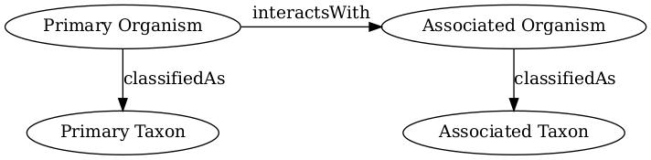
Biotic Interaction Data Model
In this review, biotic interactions (or biotic associations) are modeled as a primary (aka subject, source) organism interacting with an associate (aka object, target) organism. The dataset under review classified the primary/associate organisms with specific taxa. The primary and associate organisms The kind of interaction is documented as an interaction type.
The dataset under review, named globalbioticinteractions/limbu2025, has fingerprint hash://md5/cdc6545ee343cc33587ef7b51f265da5, is 12.6MiB in size and contains 37,571 interactions with 2 unique types of associations (e.g., coOccursWith) between 281 primary taxa (e.g., Entrophospora lamellosum) and 2,008 associated taxa (e.g., Zea mays).
An exhaustive list of indexed interaction claims can be found in gzipped csv, tsv, geopackage and parquet archives. To facilitate discovery, a preview of claims available in the gzipped html page at indexed-interactions.html.gz are shown below.
The exhaustive list was used to create the following data summaries below.
Sample of Indexed Interaction Claims
sourceTaxonName | interactionTypeName | targetTaxonName | referenceCitation
Acaulospora alpina | hasHost | Homogyne alpina | S. Pehim Limbu, S.L. Stürmer, G. Zahn, C.A. Aguilar-Trigueros, N. Rogers, & V.B. Chaudhary, Climate-linked biogeography of mycorrhizal fungal spore traits, Proc. Natl. Acad. Sci. U.S.A. 122 (29) e2505059122, https://doi.org/10.1073/pnas.2505059122 (2025). Accessed at https://github.com/globalbioticinteractions/limbu2025/archive/461a5f43a0ceadec056ca19816e9209ea8b317b1.zip on 31 Mar 2026.
Acaulospora alpina | hasHost | Capsicum annuum | S. Pehim Limbu, S.L. Stürmer, G. Zahn, C.A. Aguilar-Trigueros, N. Rogers, & V.B. Chaudhary, Climate-linked biogeography of mycorrhizal fungal spore traits, Proc. Natl. Acad. Sci. U.S.A. 122 (29) e2505059122, https://doi.org/10.1073/pnas.2505059122 (2025). Accessed at https://github.com/globalbioticinteractions/limbu2025/archive/461a5f43a0ceadec056ca19816e9209ea8b317b1.zip on 31 Mar 2026.
Acaulospora alpina | hasHost | Armeria maritima | S. Pehim Limbu, S.L. Stürmer, G. Zahn, C.A. Aguilar-Trigueros, N. Rogers, & V.B. Chaudhary, Climate-linked biogeography of mycorrhizal fungal spore traits, Proc. Natl. Acad. Sci. U.S.A. 122 (29) e2505059122, https://doi.org/10.1073/pnas.2505059122 (2025). Accessed at https://github.com/globalbioticinteractions/limbu2025/archive/461a5f43a0ceadec056ca19816e9209ea8b317b1.zip on 31 Mar 2026.
Acaulospora alpina | hasHost | Baccharis magellanica | S. Pehim Limbu, S.L. Stürmer, G. Zahn, C.A. Aguilar-Trigueros, N. Rogers, & V.B. Chaudhary, Climate-linked biogeography of mycorrhizal fungal spore traits, Proc. Natl. Acad. Sci. U.S.A. 122 (29) e2505059122, https://doi.org/10.1073/pnas.2505059122 (2025). Accessed at https://github.com/globalbioticinteractions/limbu2025/archive/461a5f43a0ceadec056ca19816e9209ea8b317b1.zip on 31 Mar 2026.

Most Frequently Mentioned Interaction Types (up to 20 most frequent)
interactionTypeName | count
coOccursWith | 19436
hasHost | 18135

Most Frequently Mentioned Primary Taxa (up to 20 most frequent)
sourceTaxonName | count
Entrophospora lamellosum | 4302
Rhizophagus intraradices | 2557
Funneliformis mosseae | 1804
Diversispora epigaea | 1125
Archaeospora trappei | 1106
Paraglomus laccatum | 1033
Gigaspora decipiens | 944
Funneliformis caledonium | 916
Septoglomus viscosum | 867
Entrophospora etunicatum | 737
Entrophospora claroideum | 682
Septoglomus constrictum | 674
Rhizophagus irregularis | 643
Funneliformis geosporus | 641
Rhizophagus fasciculatus | 634
Paraglomus brasilianum | 628
Paraglomus occultum | 623
Racocetra castanea | 609
Acaulospora scrobiculata | 591

Most Frequently Mentioned Associate Taxa (up to 20 most frequent)
targetTaxonName | count
Zea mays | 1459
Plantago lanceolata | 1415
Triticum aestivum | 1278
Festuca rubra | 1035
Helictotrichon pubescens | 1001
Arrhenatherum elatius | 505
Vitis vinifera | 430
Daucus carota | 422
soybean | 410
Coffea arabica | 383
Eragostis tef | 381
Theobroma cacao | 374
Mangifera indica | 349
corn | 346
Pinus contorta | 312
Solanum tuberosum | 244
Achillea millefolium | 240
Litchi chinensis | 235
Mimosa tenuiflora | 225

Most Frequent Interactions between Primary and Associate Taxa (up to 20 most frequent)
sourceTaxonName | interactionTypeName | targetTaxonName | count
Entrophospora lamellosum | coOccursWith | Plantago lanceolata | 409
Entrophospora lamellosum | coOccursWith | Pinus contorta | 302
Paraglomus laccatum | coOccursWith | Plantago lanceolata | 264
Entrophospora lamellosum | coOccursWith | Festuca rubra | 255
Entrophospora lamellosum | coOccursWith | Helictotrichon pubescens | 254
Archaeospora trappei | coOccursWith | Plantago lanceolata | 220
Diversispora epigaea | coOccursWith | Plantago lanceolata | 213
Paraglomus laccatum | coOccursWith | Festuca rubra | 192
Paraglomus laccatum | coOccursWith | Helictotrichon pubescens | 192
Diversispora epigaea | coOccursWith | Festuca rubra | 189
Diversispora epigaea | coOccursWith | Helictotrichon pubescens | 189
Entrophospora lamellosum | coOccursWith | Triticum aestivum | 185
Archaeospora trappei | coOccursWith | Festuca rubra | 183
Archaeospora trappei | coOccursWith | Helictotrichon pubescens | 183
Funneliformis caledonium | coOccursWith | Triticum aestivum | 165
Rhizophagus intraradices | coOccursWith | Plantago lanceolata | 144
Funneliformis mosseae | coOccursWith | Zea mays | 134
Rhizophagus intraradices | coOccursWith | Triticum aestivum | 123
Entrophospora lamellosum | coOccursWith | Zea mays | 114

Interaction Networks
The figures below provide a graph view on the dataset under review. The first shows a summary network on the kingdom level, and the second shows how interactions on the family level. It is important to note that both network graphs were first aligned taxonomically using the Catalogue of Life. Please refer to the original (or verbatim) taxonomic names for a more original view on the interaction data.
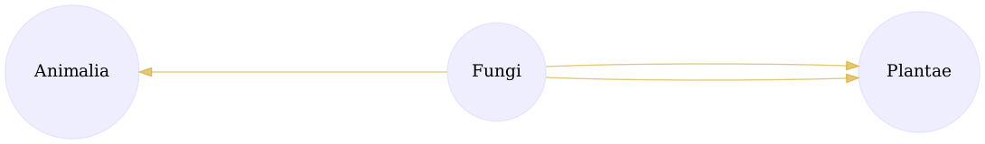
Interactions on taxonomic kingdom rank as interpreted by the Catalogue of Life download svg
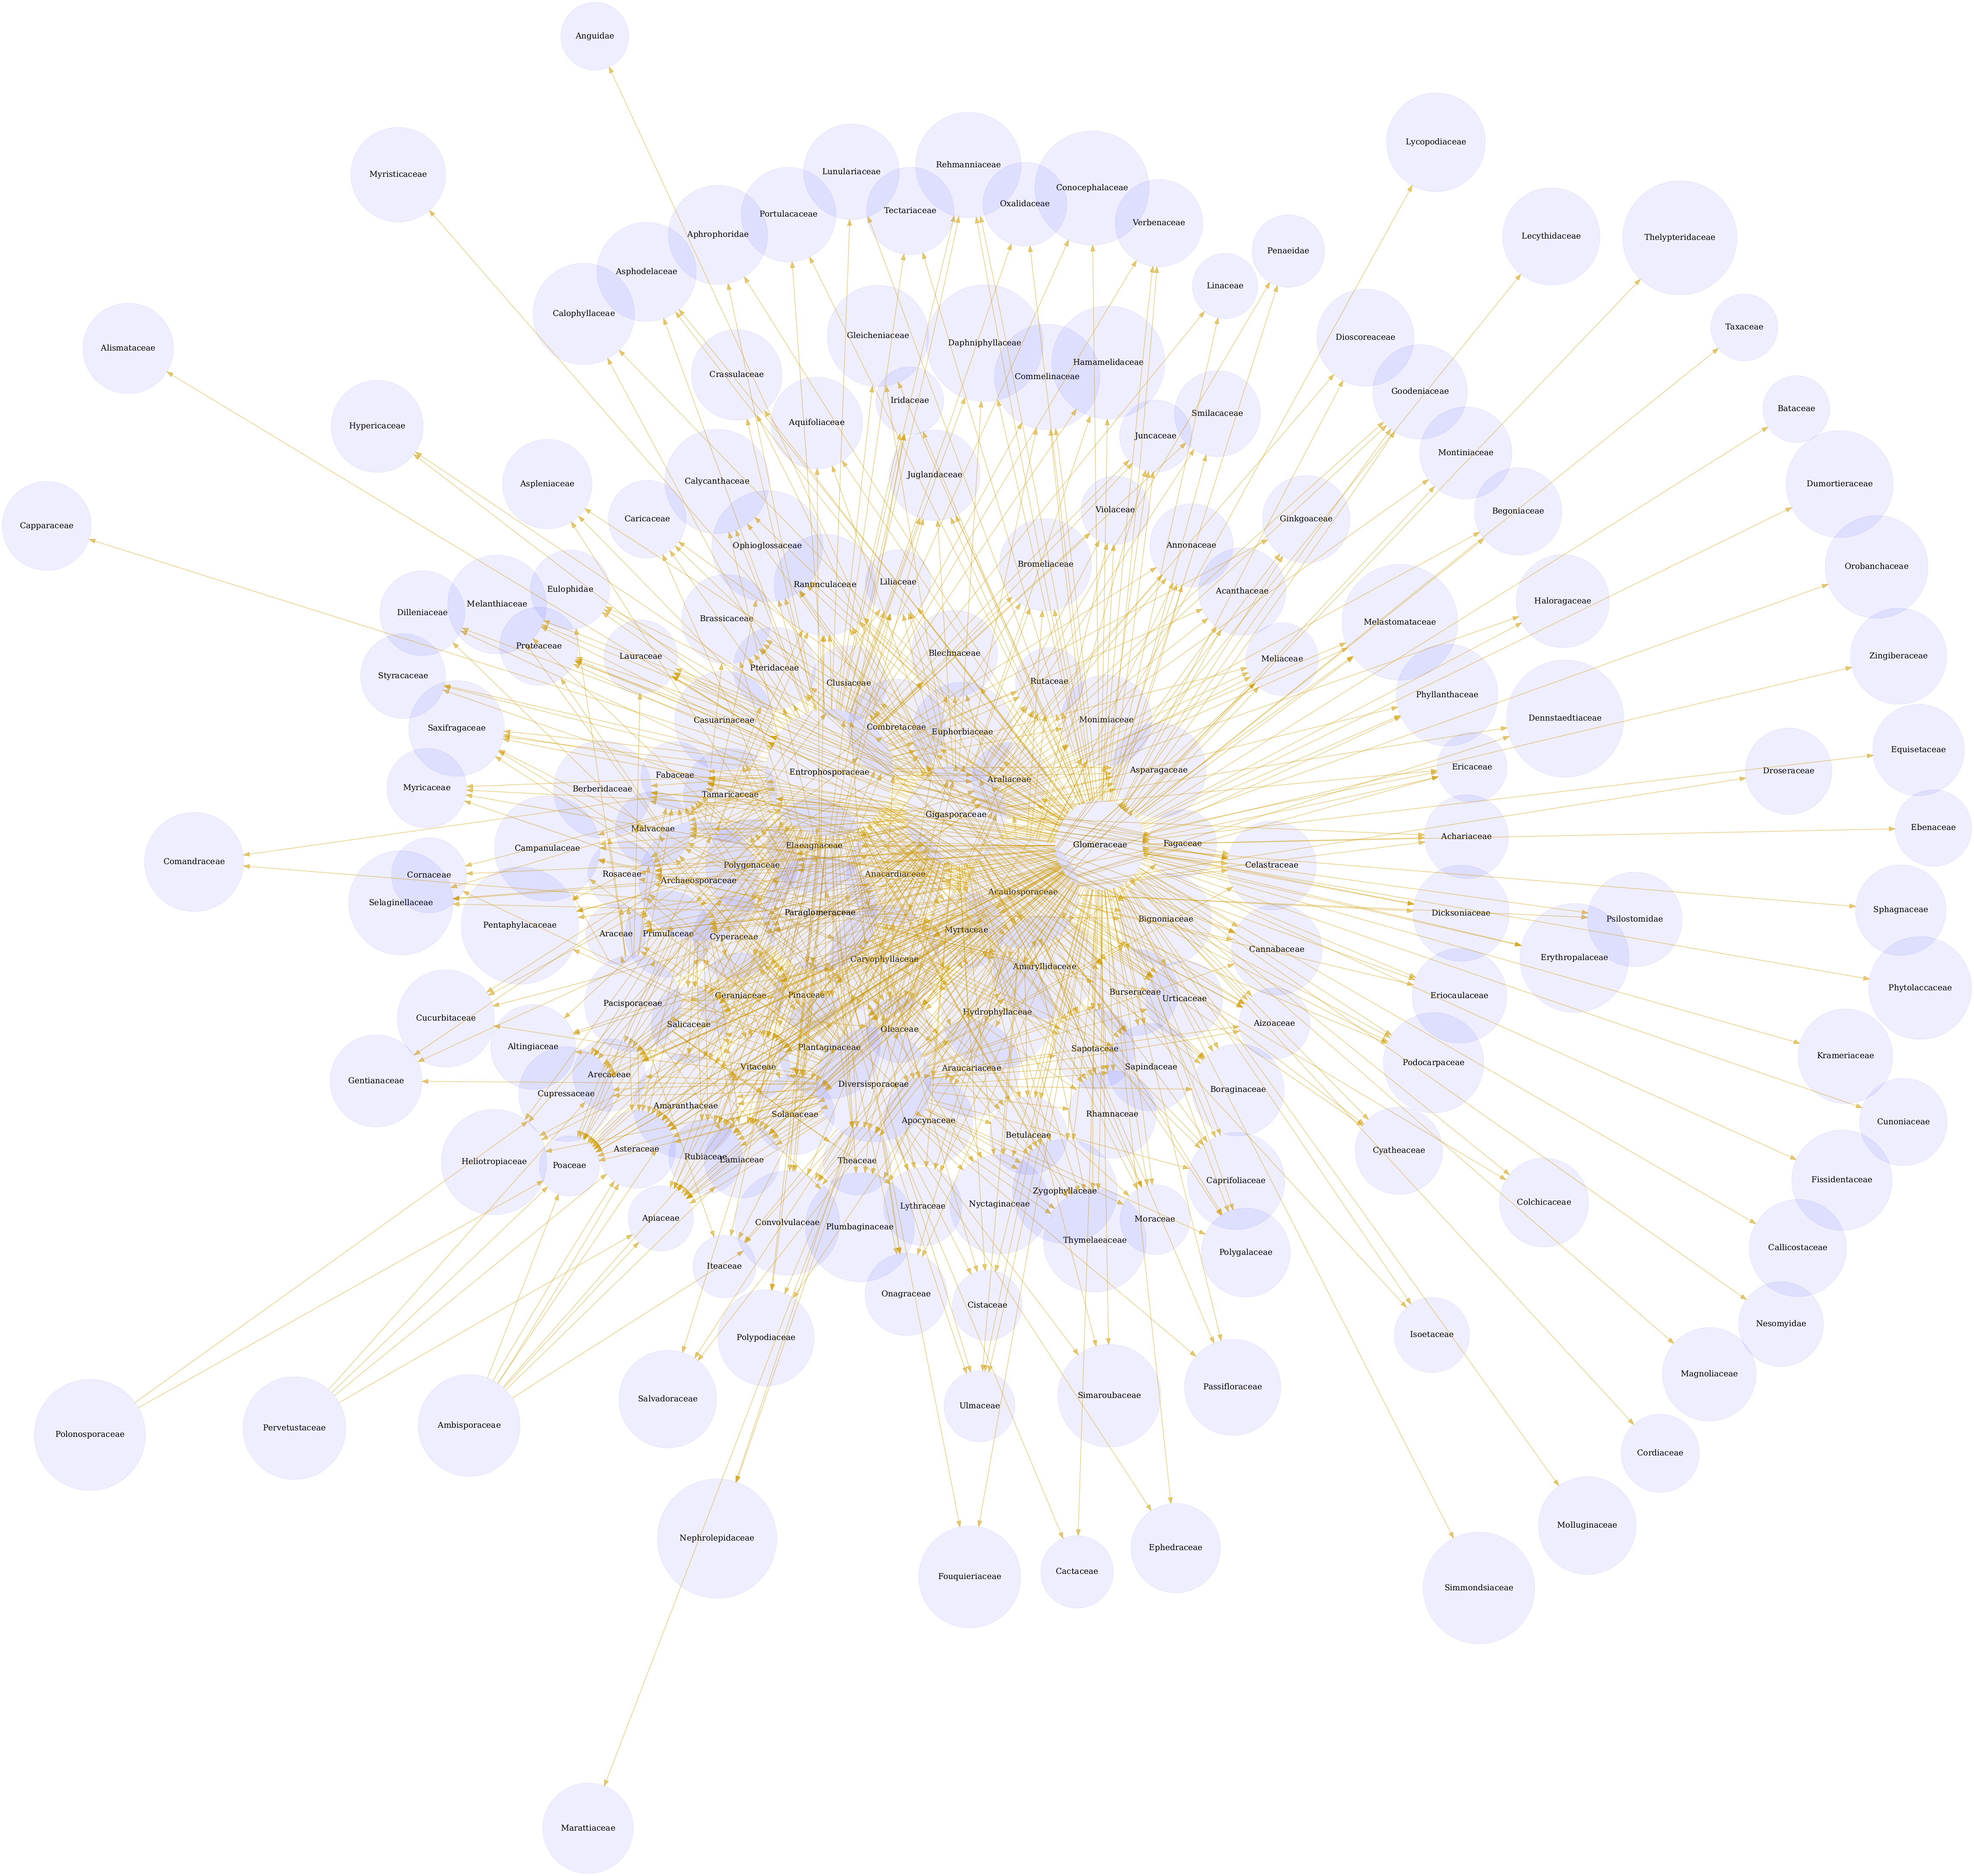
Interactions on the taxonomic family rank as interpreted by the Catalogue of Life. download svg
You can download the indexed dataset under review at indexed-interactions.csv.gz. A tab-separated file can be found at indexed-interactions.tsv.gz

Geospatial Distribution
If geospatial information was extracted from the dataset under review, the map below will show their distribution. These maps were generated using MapServer (McKenna et al. 2025) tools configured via map configuration indexed-interactions.map :
MAP
SIZE 1600 800
EXTENT -180 -90 180 90
PROJECTION
"init=epsg:4326"
END
LAYER # MODIS WMS map from NASA
NAME "modis_nasa"
TYPE RASTER
OFFSITE 0 0 0
STATUS ON
CONNECTIONTYPE WMS
CONNECTION "https://gibs.earthdata.nasa.gov/wms/epsg4326/best/wms.cgi?"
METADATA
"wms_srs" "EPSG:4326"
"wms_name" "OSM_Land_Water_Map"
"wms_server_version" "1.1.1"
"wms_format" "image/jpeg"
END
CLASS
STYLE
COLOR 232 232 232
OUTLINECOLOR 32 32 32
END
END
END
LAYER
NAME "indexed-interactions"
TYPE POLYGON
STATUS ON
CONNECTIONTYPE OGR
CONNECTION "indexed-interactions-h3.gpkg"
DATA "indexed-interactions-h3"
CLASS
STYLE
COLORRANGE 253.0 231.0 37.0 32.0 164.0 134.0
DATARANGE 0.3010299956639812 3.490660653356137
RANGEITEM "log_number_of_records"
OUTLINECOLOR 0 0 0
END
END
END
END
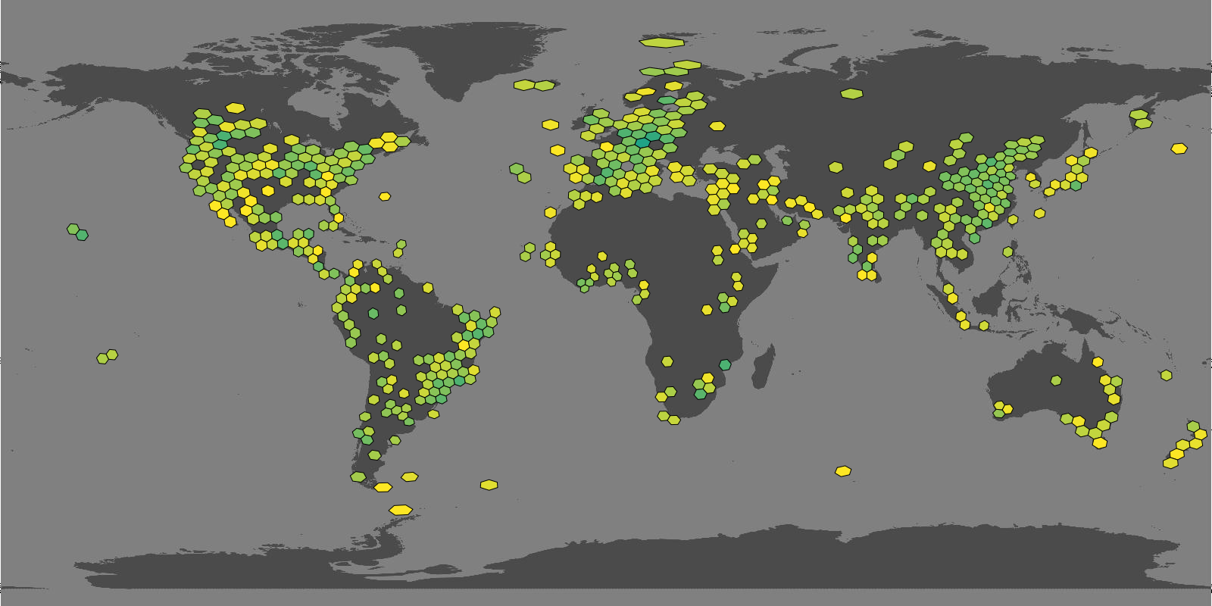
Hexagonal grid cells indicate that interactions claims are available for selected geospatial area: light yellow means relatively fewer claims, dark green relatively more claims.
Associated data can be found in the geopackage files at indexed-interactions.gpkg for point data and indexed-interactions-h3.gpkg for data clustered in geospatial h3 hexagonals.
Learn more about the structure of this download at GloBI website, by opening a GitHub issue, or by sending an email.
Another way to discover the dataset under review is by searching for it on the GloBI website.

Taxonomic Alignment
As part of the review, all names are aligned against various name catalogs (e.g., col, ncbi, discoverlife, gbif, itis, wfo, mdd, tpt, pbdb, and worms). These alignments can help review name usage or aid in selecting of a suitable taxonomic name resource.
Sample of Name Alignments
providedName | relationName | resolvedCatalogName | resolvedName
Belonging families | NONE | col | Belonging families
Abelmoschus esculentus | HAS_ACCEPTED_NAME | col | Abelmoschus esculentus
Abies alba | HAS_ACCEPTED_NAME | col | Abies alba
Abies amabilis | HAS_ACCEPTED_NAME | col | Abies amabilis

Distribution of Taxonomic Ranks of Aligned Names by Catalog. Names that were not aligned with a catalog are counted as NAs. So, the total number of unaligned names for a catalog will be listed in their NA row.
resolvedCatalogName | resolvedRank | count
col | NA | 468
col | family | 4
col | genus | 184
col | order | 1
col | section | 1
col | species | 1514
col | subgenus | 1
col | suborder | 1
col | subspecies | 57
col | variety | 24
discoverlife | NA | 2209
gbif | NA | 448
gbif | family | 7
gbif | genus | 187
gbif | species | 1525
gbif | subspecies | 75
gbif | variety | 32
itis | NA | 1118
itis | family | 6
itis | genus | 169
itis | order | 1
itis | species | 891
itis | suborder | 1
itis | subspecies | 9
itis | variety | 20
mdd | NA | 2209
ncbi | NA | 618
ncbi | clade | 1
ncbi | family | 4
ncbi | genus | 173
ncbi | species | 1394
ncbi | subfamily | 1
ncbi | subgenus | 2
ncbi | subspecies | 10
ncbi | varietas | 6
pbdb | NA | 2062
pbdb | family | 6
pbdb | genus | 97
pbdb | order | 1
pbdb | species | 40
pbdb | subfamily | 1
pbdb | suborder | 1
pbdb | subtribe | 1
pbdb | tribe | 1
pbdb | unranked clade | 1
tpt | NA | 2206
tpt | genus | 2
tpt | species | 1
wfo | NA | 729
wfo | family | 6
wfo | genus | 178
wfo | species | 1275
wfo | subspecies | 26
wfo | variety | 15
worms | NA | 1745
worms | family | 4
worms | genus | 121
worms | order | 1
worms | species | 336
worms | suborder | 1
worms | subspecies | 3
worms | variety | 4

Name relationship types per catalog. Name relationship type “NONE” means that a name was not recognized by the associated catalog. “SAME_AS” indicates either a “HAS_ACCEPTED_NAME” or “SYNONYM_OF” name relationship type. We recognize that “SYNONYM_OF” encompasses many types of nomenclatural synonymies (ICZN 1999) (e.g., junior synonym, senior synonyms).
resolvedCatalogName | relationName | count
col | NONE | 495
col | HAS_ACCEPTED_NAME | 1543
col | SYNONYM_OF | 609
discoverlife | NONE | 2289
gbif | NONE | 474
gbif | HAS_ACCEPTED_NAME | 1973
gbif | SYNONYM_OF | 1043
itis | NONE | 1147
itis | HAS_ACCEPTED_NAME | 974
itis | SYNONYM_OF | 244
mdd | NONE | 2289
ncbi | NONE | 645
ncbi | SAME_AS | 1452
ncbi | SYNONYM_OF | 202
ncbi | COMMON_NAME_OF | 2
pbdb | NONE | 2120
pbdb | HAS_ACCEPTED_NAME | 173
pbdb | SYNONYM_OF | 5
tpt | NONE | 2286
tpt | HAS_ACCEPTED_NAME | 3
wfo | NONE | 758
wfo | HAS_ACCEPTED_NAME | 1330
wfo | SYNONYM_OF | 376
wfo | HAS_UNCHECKED_NAME | 135
worms | NONE | 1791
worms | HAS_ACCEPTED_NAME | 509
worms | SYNONYM_OF | 103

List of Available Name Alignment Reports
catalog name | alignment results
col | associated names alignments report in gzipped html, csv, and tsv)
ncbi | associated names alignments report in gzipped html, csv, and tsv)
discoverlife | associated names alignments report in gzipped html, csv, and tsv)
gbif | associated names alignments report in gzipped html, csv, and tsv)
itis | associated names alignments report in gzipped html, csv, and tsv)
wfo | associated names alignments report in gzipped html, csv, and tsv)
mdd | associated names alignments report in gzipped html, csv, and tsv)
tpt | associated names alignments report in gzipped html, csv, and tsv)
pbdb | associated names alignments report in gzipped html, csv, and tsv)
worms | associated names alignments report in gzipped html, csv, and tsv)

Additional Reviews
Elton, Nomer, and other tools may have difficulties interpreting existing species interaction datasets. Or, they may misbehave, or otherwise show unexpected behavior. As part of the review process, detailed review notes are kept that document possibly misbehaving, or confused, review bots. An sample of review notes associated with this review can be found below.
First few lines in the review notes.
reviewDate | reviewCommentType | reviewComment
2026-03-30T23:41:35Z | note | target taxon name missing
2026-03-30T23:41:35Z | note | target taxon name missing
2026-03-30T23:41:35Z | note | target taxon name missing
2026-03-30T23:41:35Z | note | target taxon name missing
In addition, you can find the most frequently occurring notes in the table below.
Most frequently occurring review notes, if any.
reviewComment | count
target taxon name missing | 49502
For additional information on review notes, please have a look at the first 500 Review Notes in html format or the download full gzipped csv or tsv archives.

GloBI Review Badge
As part of the review, a review badge is generated. This review badge can be included in webpages to indicate the review status of the dataset under review.
Picture of a GloBI Review Badge
Note that if the badge is green, no review notes were generated. If the badge is yellow, the review bots may need some help with interpreting the species interaction data.

GloBI Index Badge
If the dataset under review has been registered with GloBI, and has been succesfully indexed by GloBI, the GloBI Index Status Badge will turn green. This means that the dataset under review was indexed by GloBI and is available through GloBI services and derived data products.
Picture of a GloBI Index Badge
If you’d like to keep track of reviews or index status of the dataset under review, please visit GloBI’s dataset index for badge examples.

Discussion
This review and archive provides a means of creating citable versions of datasets that change frequently. This may be useful for dataset managers, including natural history collection data managers, as a backup archive of a shared Darwin Core archive. It also serves as a means of creating a trackable citation for the dataset in an automated way, while also including some information about the contents of the dataset.
This review aims to provide a perspective on the dataset to aid in understanding of species interaction claims discovered. However, it is important to note that this review does not assess the quality of the dataset. Instead, it serves as an indication of the open-ness and FAIRness (Wilkinson et al. 2016; Trekels et al. 2023) of the dataset: to perform this review, the data was likely openly available, Findable, Accessible, Interoperable and Reusable. The current Open-FAIR assessment is qualitative, and a more quantitative approach can be implemented with specified measurement units.
This report also showcases the reuse of machine-actionable (meta)data, something highly recommended by the FAIR Data Principles (Wilkinson et al. 2016). Making (meta)data machine-actionable enables more precise procesing by computers, enabling even naive review bots like Nomer and Elton to interpret the data effectively. This capability is crucial for not just automating the generation of reports, but also for facilitating seamless data exchanges, promoting interoperability.

Acknowledgements
We thank the many humans that created us and those who created and maintained the data, software and other intellectual resources that were used for producing this review. In addition, we are grateful for the natural resources providing the basis for these human and bot activities. Also, thanks to https://github.com/zygoballus for helping improve the layout of the review tables.

Author contributions
Nomer was responsible for name alignments. Elton carried out dataset extraction, and generated the review notes. Preston tracked, versioned, and packaged, the dataset under review.

References
Elliott, Michael, Jorrit Poelen, Icaro Alzuru, Emilio Berti, and partha04patel. 2025. “Bio-Guoda/Preston: 0.10.5.” Zenodo. https://doi.org/10.5281/zenodo.14662206.
ICZN. 1999. “International Code of Zoological Nomenclature.” The International Trust for Zoological Nomenclature, London, UK. https://www.iczn.org/the-code/the-code-online/.
Kuhn, Tobias, and Michel Dumontier. 2014. “Trusty URIs: Verifiable, Immutable, and Permanent Digital Artifacts for Linked Data.” In The Semantic Web: Trends and Challenges, edited by Valentina Presutti, Claudia d’Amato, Fabien Gandon, Mathieu d’Aquin, Steffen Staab, and Anna Tordai, 395–410. Cham: Springer International Publishing.
Kuhn, Tobias, Jorrit Poelen, and Katrin Leinweber. 2025. “Globalbioticinteractions/Elton: 0.15.1.” Zenodo. https://doi.org/10.5281/zenodo.14927734.
McKenna, Jeff, Steve Lime, Thomas Bonfort, Jérome Boué, Howard Butler, Seth Girvin, Tom Kralidis, et al. 2025. “MapServer.” Zenodo. https://doi.org/10.5281/zenodo.17807263.
Poelen, Jorrit H. (ed.). 2024. “Nomer Corpus of Taxonomic Resources Hash://Sha256/ B60c0d25a16ae77b24305782017b1a270b79b5d1746f832650 F2027ba536e276 Hash://Md5/17f1363a277ee0e4ecaf1b91c665e47e.” Zenodo. https://doi.org/10.5281/zenodo.12695629.
Poelen, Jorrit H., James D. Simons, and Chris J. Mungall. 2014. “Global Biotic Interactions: An Open Infrastructure to Share and Analyze Species-Interaction Datasets.” Ecological Informatics 24 (November): 148–59. https://doi.org/10.1016/j.ecoinf.2014.08.005.
Poelen, Jorrit, Katja Seltmann, and Daniel Mietchen. 2024. “Globalbioticinteractions/Globinizer: 0.4.0.” Zenodo. https://doi.org/10.5281/zenodo.10647565.
Salim, José Augusto, and Jorrit Poelen. 2025. “Globalbioticinteractions/Nomer: 0.5.15.” Zenodo. https://doi.org/10.5281/zenodo.14893840.
Trekels, Maarten, Debora Pignatari Drucker, José Augusto Salim, Jeff Ollerton, Jorrit Poelen, Filipi Miranda Soares, Max Rünzel, Muo Kasina, Quentin Groom, and Mariano Devoto. 2023. “WorldFAIR Project (D10.1) Agriculture-related pollinator data standards use cases report.” Zenodo. https://doi.org/10.5281/zenodo.8176978.
Wilkinson, Mark D., Michel Dumontier, IJsbrand Jan Aalbersberg, Gabrielle Appleton, Myles Axton, Arie Baak, Niklas Blomberg, et al. 2016. “The FAIR Guiding Principles for Scientific Data Management and Stewardship.” Scientific Data 3 (1). https://doi.org/10.1038/sdata.2016.18.

Note that you have to first get the data (e.g., via elton pull globalbioticinteractions/limbu2025) before being able to generate reviews (e.g., elton review globalbioticinteractions/limbu2025), extract interaction claims (e.g., elton interactions globalbioticinteractions/limbu2025), or list taxonomic names (e.g., elton names globalbioticinteractions/limbu2025)
Disclaimer: The results in this review should be considered friendly, yet naive, notes from an unsophisticated robot. Please keep that in mind when considering the review results.
Up-to-date status of the GloBI Review Badge can be retrieved from the GloBI Review Depot
Up-to-date status of the GloBI Index Badge can be retrieved from GloBI’s API
At time of writing (2026-03-31) the version of the GloBI dataset index was available at https://globalbioticinteractions.org/datasets
According to http://opendefinition.org/: “Open data is data that can be freely used, re-used and redistributed by anyone - subject only, at most, to the requirement to attribute and sharealike.”

