Versioned Archive and Review of Biotic Interactions and Taxon Names Found within ibartomeus/CropPol hash://md5/d312bbc5135466831377f8b9f23ebffa
by Nomer, Elton and Preston, three naive review bots
review@globalbioticinteractions.org
https://globalbioticinteractions.org/contribute
https://github.com/ibartomeus/CropPol/issues
2026-02-02
Abstract
Life on Earth is sustained by complex interactions between organisms and their environment. These biotic interactions can be captured in datasets and published digitally. We present a review and archiving process for such an openly accessible digital interactions dataset of known origin and discuss its outcome. The dataset under review, named ibartomeus/CropPol, has fingerprint hash://md5/d312bbc5135466831377f8b9f23ebffa, is 77.2MiB in size and contains 54,191 interactions with 1 unique type of association (e.g., pollinatedBy) between 46 primary taxa (e.g., Malus domestica) and 2,961 associated taxa (e.g., Apis mellifera). This report includes detailed summaries of interaction data, a taxonomic review from multiple catalogs, and an archived version of the dataset from which the reviews are derived.
Table of Contents

Introduction

Data Review and Archive
Data review and archiving can be a time-consuming process, especially when done manually. This review report aims to help facilitate both activities. It automates the archiving of datasets, including Darwin Core archives, and is a citable backup of a version of the dataset. Additionally, an automatic review of species interaction claims made in the dataset is generated and registered with Global Biotic Interactions (J. H. Poelen, Simons, and Mungall 2014).
This review includes summary statistics about, and observations about, the dataset under review :
Allen-Perkins, Alfonso, Magrach, Ainhoa, Dainese, Matteo, Garibaldi, Lucas A., Kleijn, David, Rader, Romina, Reilly, James R., et al. 2022. “CropPol: A Dynamic, Open and Global Database on Crop Pollination.” Ecology 103(3): e3614. https://doi.org/10.1002/ecy.3614 https://github.com/ibartomeus/CropPol/archive/8353d98c342da5365621056b16cf445a083c6f0a.zip 2026-01-31T09:17:28.815Z hash://md5/d312bbc5135466831377f8b9f23ebffa
For additional metadata related to this dataset, please visit https://github.com/ibartomeus/CropPol and inspect associated metadata files including, but not limited to, README.md, eml.xml, and/or globi.json.

Methods
The review is performed through programmatic scripts that leverage tools like Preston (Elliott et al. 2025), Elton (Kuhn, Poelen, and Leinweber 2025), Nomer (Salim and Poelen 2025), globinizer (J. Poelen, Seltmann, and Mietchen 2024) combined with third-party tools like grep, mlr, tail and head.
Tools used in this review process
tool name | version
preston | 0.11.1
elton | 0.16.4
nomer | 0.5.17
globinizer | 0.4.0
mlr | 6.0.0
jq | 1.6
yq | 4.25.3
pandoc | 3.1.6.1
duckdb | 1.3.1
mapserver | 7.6.4
The review process can be described in the form of the script below .
# get versioned copy of the dataset (size approx. 77.2MiB) under review
elton pull ibartomeus/CropPol
# generate review notes
elton review ibartomeus/CropPol\
> review.tsv
# export indexed interaction records
elton interactions ibartomeus/CropPol\
> interactions.tsv
# export names and align them with the Catalogue of Life using Nomer
elton names ibartomeus/CropPol\
| nomer append col\
> name-alignment.tsv
or visually, in a process diagram.
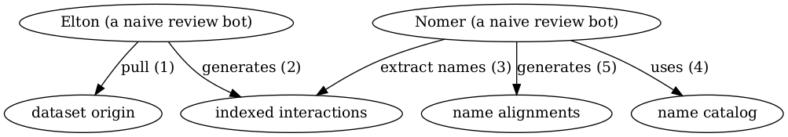
Review Process Overview
You can find a copy of the full review script at check-data.sh. See also GitHub and Codeberg.

Results
In the following sections, the results of the review are summarized . Then, links to the detailed review reports are provided.

Files
The following files are produced in this review:
filename | description
biblio.bib | list of bibliographic reference of this review
check-dataset.sh | data review workflow/process as expressed in a bash script
data.zip | a versioned archive of the data under review
HEAD | the digital signature of the data under review
index.docx | review in MS Word format
index.html | review in HTML format
index.md | review in Pandoc markdown format
index.pdf | review in PDF format
indexed-citations.csv.gz | list of distinct reference citations for reviewed species interaction claims in gzipped comma-separated values file format
indexed-citations.html.gz | list of distinct reference citations for reviewed species interactions claims in gzipped html file format
indexed-citations.tsv.gz | list of distinct reference citations for reviewed species interaction claims in gzipped tab-separated values format
indexed-interactions-col-family-col-family.svg | network diagram showing the taxon family to taxon family interaction claims in the dataset under review as interpreted by the Catalogue of Life via Nomer Corpus of Taxonomic Resources (J. H. (ed. ). Poelen 2024)
indexed-interactions-col-kingdom-col-kingdom.svg | network diagram showing the taxon kingdom to taxon kingom interaction claims in the dataset under review as interpreted by the Catalogue of Life via Nomer Corpus of Taxonomic Resources (J. H. (ed. ). Poelen 2024)
indexed-interactions.csv.gz | species interaction claims indexed from the dataset under review in gzipped comma-separated values format
indexed-interactions.html.gz | species interaction claims indexed from the dataset under review in gzipped html format
indexed-interactions.tsv.gz | species interaction claims indexed from the dataset under review in gzipped tab-separated values format
indexed-interactions.parquet | species interaction claims indexed from the dataset under review in Apache Parquet format
indexed-interactions.png | species interaction claims indexed from the dataset under review plotted on a map
indexed-interactions.gpkg | species interaction claims indexed from the dataset under review in GeoPackage format
indexed-interactions-h3.gpkg | geospatially clustered h3 species interaction claims indexed from the dataset under review in GeoPackage format
indexed-interactions-sample.csv | list of species interaction claims indexed from the dataset under review in gzipped comma-separated values format
indexed-interactions-sample.html | first 500 species interaction claims indexed from the dataset under review in html format
indexed-interactions-sample.tsv | first 500 species interaction claims indexed from the dataset under review in tab-separated values format
indexed-names.csv.gz | taxonomic names indexed from the dataset under review in gzipped comma-separated values format
indexed-names.html.gz | taxonomic names found in the dataset under review in gzipped html format
indexed-names.tsv.gz | taxonomic names found in the dataset under review in gzipped tab-separated values format
indexed-names.parquet | taxonomic names found in the dataset under review in Apache Parquet format
indexed-names-resolved-col.csv.gz | taxonomic names found in the dataset under review aligned with the Catalogue of Life as accessed through the Nomer Corpus of Taxonomic Resources (J. H. (ed. ). Poelen 2024) in gzipped comma-separated values format
indexed-names-resolved-col.html.gz | taxonomic names found in the dataset under review aligned with the Catalogue of Life as accessed through the Nomer Corpus of Taxonomic Resources (J. H. (ed. ). Poelen 2024) in gzipped html format
indexed-names-resolved-col.tsv.gz | taxonomic names found in the dataset under review aligned with the Catalogue of Life as accessed through the Nomer Corpus of Taxonomic Resources (J. H. (ed. ). Poelen 2024) in gzipped tab-separated values format
indexed-names-resolved-col.parquet | taxonomic names found in the dataset under review aligned with the Catalogue of Life as accessed through the Nomer Corpus of Taxonomic Resources (J. H. (ed. ). Poelen 2024) in Apache Parquet format
indexed-names-resolved-discoverlife.csv.gz | taxonomic names found in the dataset under review aligned with Discover Life bee species checklist as accessed through the Nomer Corpus of Taxonomic Resources (J. H. (ed. ). Poelen 2024) in gzipped comma-separated values format
indexed-names-resolved-discoverlife.html.gz | taxonomic names found in the dataset under review aligned with Discover Life bee species checklist as accessed through the Nomer Corpus of Taxonomic Resources (J. H. (ed. ). Poelen 2024) in gzipped html format
indexed-names-resolved-discoverlife.tsv.gz | taxonomic names found in the dataset under review aligned with Discover Life bee species checklist as accessed through the Nomer Corpus of Taxonomic Resources (J. H. (ed. ). Poelen 2024) in gzipped tab-separated values format
indexed-names-resolved-discoverlife.parquet | taxonomic names found in the dataset under review aligned with Discover Life bee species checklist as accessed through the Nomer Corpus of Taxonomic Resources (J. H. (ed. ). Poelen 2024) in Apache Parquet format
indexed-names-resolved-gbif.csv.gz | taxonomic names found in the dataset under review aligned with GBIF Backbone Taxonomy as accessed through the Nomer Corpus of Taxonomic Resources (J. H. (ed. ). Poelen 2024) in gzipped comma-separated values format
indexed-names-resolved-gbif.html.gz | taxonomic names found in the dataset under review aligned with GBIF Backbone Taxonomy as accessed through the Nomer Corpus of Taxonomic Resources (J. H. (ed. ). Poelen 2024) in gzipped html format
indexed-names-resolved-gbif.tsv.gz | taxonomic names found in the dataset under review aligned with GBIF Backbone Taxonomy as accessed through the Nomer Corpus of Taxonomic Resources (J. H. (ed. ). Poelen 2024) in gzipped tab-separated values format
indexed-names-resolved-gbif.parquet | taxonomic names found in the dataset under review aligned with GBIF Backbone Taxonomy as accessed through the Nomer Corpus of Taxonomic Resources (J. H. (ed. ). Poelen 2024) in Apache Parquet format
indexed-names-resolved-itis.csv.gz | taxonomic names found in the dataset under review aligned with Integrated Taxonomic Information System (ITIS) as accessed through the Nomer Corpus of Taxonomic Resources (J. H. (ed. ). Poelen 2024) in gzipped comma-separated values format
indexed-names-resolved-itis.html.gz | taxonomic names found in the dataset under review aligned with Integrated Taxonomic Information System (ITIS) as accessed through the Nomer Corpus of Taxonomic Resources (J. H. (ed. ). Poelen 2024) in gzipped html format
indexed-names-resolved-itis.tsv.gz | taxonomic names found in the dataset under review aligned with Integrated Taxonomic Information System (ITIS) as accessed through the Nomer Corpus of Taxonomic Resources (J. H. (ed. ). Poelen 2024) in gzipped tab-separated values format
indexed-names-resolved-itis.parquet | taxonomic names found in the dataset under review aligned with Integrated Taxonomic Information System (ITIS) as accessed through the Nomer Corpus of Taxonomic Resources (J. H. (ed. ). Poelen 2024) in Apache Parquet format
indexed-names-resolved-mdd.csv.gz | taxonomic names found in the dataset under review aligned with the Mammal Diversity Database as accessed through the Nomer Corpus of Taxonomic Resources (J. H. (ed. ). Poelen 2024) in gzipped comma-separated values format
indexed-names-resolved-mdd.html.gz | taxonomic names found in the dataset under review aligned with Mammal Diversity Database as accessed through the Nomer Corpus of Taxonomic Resources (J. H. (ed. ). Poelen 2024) in gzipped html format
indexed-names-resolved-mdd.tsv.gz | taxonomic names found in the dataset under review aligned with Mammal Diversity Database as accessed through the Nomer Corpus of Taxonomic Resources (J. H. (ed. ). Poelen 2024) in gzipped tab-separated values format
indexed-names-resolved-mdd.parquet | taxonomic names found in the dataset under review aligned with Mammal Diversity Database as accessed through the Nomer Corpus of Taxonomic Resources (J. H. (ed. ). Poelen 2024) in Apache Parquet format
indexed-names-resolved-ncbi.csv.gz | taxonomic names found in the dataset under review aligned with the NCBI Taxonomy as accessed through the Nomer Corpus of Taxonomic Resources (J. H. (ed. ). Poelen 2024) in gzipped comma-separated values format
indexed-names-resolved-ncbi.html.gz | taxonomic names found in the dataset under review aligned with the NCBI Taxonomy as accessed through the Nomer Corpus of Taxonomic Resources (J. H. (ed. ). Poelen 2024) in gzipped html format
indexed-names-resolved-ncbi.tsv.gz | taxonomic names found in the dataset under review aligned with the NCBI Taxonomy as accessed through the Nomer Corpus of Taxonomic Resources (J. H. (ed. ). Poelen 2024) in gzipped tab-separated values format
indexed-names-resolved-ncbi.parquet | taxonomic names found in the dataset under review aligned with the NCBI Taxonomy as accessed through the Nomer Corpus of Taxonomic Resources (J. H. (ed. ). Poelen 2024) in Apache Parquet format
indexed-names-resolved-pbdb.csv.gz | taxonomic names found in the dataset under review aligned with the Paleobiology Database as accessed through the Nomer Corpus of Taxonomic Resources (J. H. (ed. ). Poelen 2024) in gzipped comma-separated values format
indexed-names-resolved-pbdb.html.gz | taxonomic names found in the dataset under review aligned with Paleobiology Database as accessed through the Nomer Corpus of Taxonomic Resources (J. H. (ed. ). Poelen 2024) in gzipped html format
indexed-names-resolved-pbdb.tsv.gz | taxonomic names found in the dataset under review aligned with Paleobiology Database as accessed through the Nomer Corpus of Taxonomic Resources (J. H. (ed. ). Poelen 2024) in gzipped tab-separated values format
indexed-names-resolved-pbdb.parquet | taxonomic names found in the dataset under review aligned with Paleobiology Database as accessed through the Nomer Corpus of Taxonomic Resources (J. H. (ed. ). Poelen 2024) in Apache Parquet format
indexed-names-resolved-tpt.csv.gz | taxonomic names found in the dataset under review aligned with the Terrestrial Parasite Tracker (TPT) Taxonomic Resource as accessed through the Nomer Corpus of Taxonomic Resources (J. H. (ed. ). Poelen 2024) in gzipped comma-separated values format
indexed-names-resolved-tpt.html.gz | taxonomic names found in the dataset under review aligned with the Terrestrial Parasite Tracker (TPT) Taxonomic Resource as accessed through the Nomer Corpus of Taxonomic Resources (J. H. (ed. ). Poelen 2024) in gzipped html format
indexed-names-resolved-tpt.tsv.gz | taxonomic names found in the dataset under review aligned with the Terrestrial Parasite Tracker (TPT) Taxonomic Resource as accessed through the Nomer Corpus of Taxonomic Resources (J. H. (ed. ). Poelen 2024) in gzipped tab-separated values format
indexed-names-resolved-tpt.parquet | taxonomic names found in the dataset under review aligned with the Terrestrial Parasite Tracker (TPT) Taxonomic Resource as accessed through the Nomer Corpus of Taxonomic Resources (J. H. (ed. ). Poelen 2024) in Apache Parquet format
indexed-names-resolved-wfo.csv.gz | taxonomic names found in the dataset under review aligned with the World of Flora Online as accessed through the Nomer Corpus of Taxonomic Resources (J. H. (ed. ). Poelen 2024) in gzipped comma-separated values format
indexed-names-resolved-wfo.html.gz | taxonomic names found in the dataset under review aligned with the World of Flora Online as accessed through the Nomer Corpus of Taxonomic Resources (J. H. (ed. ). Poelen 2024) in gzipped html format
indexed-names-resolved-wfo.tsv.gz | taxonomic names found in the dataset under review aligned with the World of Flora Online as accessed through the Nomer Corpus of Taxonomic Resources (J. H. (ed. ). Poelen 2024) in gzipped tab-separated values format
indexed-names-resolved-wfo.parquet | taxonomic names found in the dataset under review aligned with the World of Flora Online as accessed through the Nomer Corpus of Taxonomic Resources (J. H. (ed. ). Poelen 2024) in Apache Parquet format
indexed-names-resolved-worms.csv.gz | taxonomic names found in the dataset under review aligned with the World Register of Marine Species (WoRMS) as accessed through the Nomer Corpus of Taxonomic Resources (J. H. (ed. ). Poelen 2024) in gzipped comma-separated values format
indexed-names-resolved-worms.html.gz | taxonomic names found in the dataset under review aligned with the World Register of Marine Species (WoRMS) as accessed through the Nomer Corpus of Taxonomic Resources (J. H. (ed. ). Poelen 2024) in gzipped html format
indexed-names-resolved-worms.tsv.gz | taxonomic names found in the dataset under review aligned with the World Register of Marine Species (WoRMS) as accessed through the Nomer Corpus of Taxonomic Resources (J. H. (ed. ). Poelen 2024) in gzipped tab-separated values format
indexed-names-resolved-worms.parquet | taxonomic names found in the dataset under review aligned with the World Register of Marine Species (WoRMS) as accessed through the Nomer Corpus of Taxonomic Resources (J. H. (ed. ). Poelen 2024) in Apache Parquet format
indexed-names-sample.csv | first 500 taxonomic names found in the dataset under review in comma-separated values format
indexed-names-sample.html | first 500 taxonomic names found in the dataset under review in html format
indexed-names-sample.tsv | first 500 taxonomic names found in the dataset under review in tab-separated values format
interaction.svg | diagram summarizing the data model used to index species interaction claims
nanopub-sample.trig | first 500 species interaction claims as expressed in the nanopub format (Kuhn and Dumontier 2014)
nanopub.trig.gz | species interaction claims as expressed in the nanopub format (Kuhn and Dumontier 2014)
process.svg | diagram summarizing the data review processing workflow
prov.nq | origin of the dataset under review as expressed in rdf/nquads
review.csv.gz | review notes associated with the dataset under review in gzipped comma-separated values format
review.html.gz | review notes associated with the dataset under review in gzipped html format
review.tsv.gz | review notes associated with the dataset under review in gzipped tab-separated values format
review-sample.csv | first 500 review notes associated with the dataset under review in comma-separated values format
review-sample.html | first 500 review notes associated with the dataset under review in html format
review-sample.tsv | first 500 review notes associated with the dataset under review in tab-separated values format
review.svg | a review badge generated as part of the dataset review process
zenodo.json | metadata of this review expressed in Zenodo record metadata

Archived Dataset
Note that data.zip file in this archive contains the complete, unmodified archived dataset under review.

Biotic Interactions
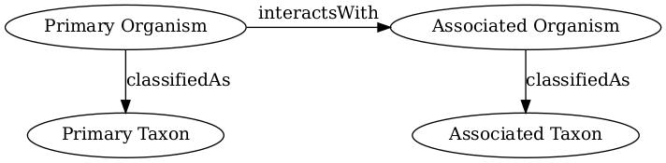
Biotic Interaction Data Model
In this review, biotic interactions (or biotic associations) are modeled as a primary (aka subject, source) organism interacting with an associate (aka object, target) organism. The dataset under review classified the primary/associate organisms with specific taxa. The primary and associate organisms The kind of interaction is documented as an interaction type.
The dataset under review, named ibartomeus/CropPol, has fingerprint hash://md5/d312bbc5135466831377f8b9f23ebffa, is 77.2MiB in size and contains 54,191 interactions with 1 unique type of association (e.g., pollinatedBy) between 46 primary taxa (e.g., Malus domestica) and 2,961 associated taxa (e.g., Apis mellifera).
An exhaustive list of indexed interaction claims can be found in gzipped csv, tsv, geopackage and parquet archives. To facilitate discovery, a preview of claims available in the gzipped html page at indexed-interactions.html.gz are shown below.
The exhaustive list was used to create the following data summaries below.
Sample of Indexed Interaction Claims
sourceTaxonName | interactionTypeName | targetTaxonName | referenceCitation
Rubus idaeus | pollinatedBy | Bombus terrestris | Agustin Saez/CONICET (Universidad Nacional del Comahue)
Rubus idaeus | pollinatedBy | Apis mellifera | Agustin Saez/CONICET (Universidad Nacional del Comahue)
Rubus idaeus | pollinatedBy | Ruizanthedella mutabilis | Agustin Saez/CONICET (Universidad Nacional del Comahue)
Rubus idaeus | pollinatedBy | Ruizantheda proxima | Agustin Saez/CONICET (Universidad Nacional del Comahue)

Most Frequently Mentioned Interaction Types (up to 20 most frequent)
interactionTypeName | count
pollinatedBy | 54191

Most Frequently Mentioned Primary Taxa (up to 20 most frequent)
sourceTaxonName | count
Malus domestica | 17213
Brassica napus | 6850
Allium porrum | 4748
Citrullus lanatus | 3504
Vaccinium macrocarpon | 3150
Vaccinium corymbosum | 3064
Helianthus annuus | 2395
Fragaria x ananassa | 2184
Coffea canephora | 1194
Coffea arabica | 1065
Vicia faba | 1007
Prunus dulcis | 773
Fagopyrum esculentum | 678
Actinidia deliciosa | 512
Gossypium hirsutum | 491
Mangifera indica | 448
Pyrus communis | 445
Coffea arabica/robusta | 439
Vaccinium meridionale | 434

Most Frequently Mentioned Associate Taxa (up to 20 most frequent)
targetTaxonName | count
Apis mellifera | 8273
Apis_mellifera | 1829
Bombus terrestris agg. | 1351
Bombus_impatiens | 1338
Bombus terrestris_agg. | 810
Lasioglossum malachurum | 754
Bombus lapidarius | 691
Bombus_bimaculatus | 598
Bombus_griseocollis | 597
Andrena haemorrhoa | 537
Andrena flavipes | 503
wild_bee_unknown | 465
Bombus terrestris | 463
Bombus_spp. | 457
Bombus pascuorum | 438
Bombus pratorum | 415
Bombus impatiens | 352
syrphids | 330
syrphidae | 317

Most Frequent Interactions between Primary and Associate Taxa (up to 20 most frequent)
sourceTaxonName | interactionTypeName | targetTaxonName | count
Malus domestica | pollinatedBy | Apis mellifera | 6127
Malus domestica | pollinatedBy | Bombus terrestris agg. | 966
Malus domestica | pollinatedBy | Bombus terrestris_agg. | 810
Vaccinium macrocarpon | pollinatedBy | Bombus_impatiens | 780
Brassica napus | pollinatedBy | Apis_mellifera | 660
Vaccinium macrocarpon | pollinatedBy | Bombus_bimaculatus | 554
Vaccinium macrocarpon | pollinatedBy | Bombus_griseocollis | 525
Malus domestica | pollinatedBy | Andrena haemorrhoa | 454
Citrullus lanatus | pollinatedBy | Apis_mellifera | 452
Citrullus lanatus | pollinatedBy | wild_bee_unknown | 447
Brassica napus | pollinatedBy | Apis mellifera | 418
Citrullus lanatus | pollinatedBy | Bombus_impatiens | 414
Malus domestica | pollinatedBy | Lasioglossum malachurum | 374
Prunus dulcis | pollinatedBy | Apis mellifera | 359
Vicia faba | pollinatedBy | syrphids | 330
Citrullus lanatus | pollinatedBy | Bombus_spp. | 327
Malus domestica | pollinatedBy | Lasioglossum algericolellum | 300
Coffea arabica/robusta | pollinatedBy | Apis | 299
Fragaria x ananassa | pollinatedBy | Apis mellifera | 288

Interaction Networks
The figures below provide a graph view on the dataset under review. The first shows a summary network on the kingdom level, and the second shows how interactions on the family level. It is important to note that both network graphs were first aligned taxonomically using the Catalogue of Life. Please refer to the original (or verbatim) taxonomic names for a more original view on the interaction data.
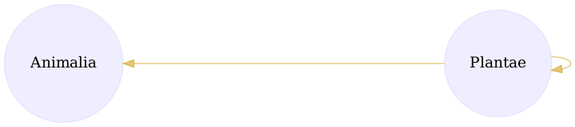
Interactions on taxonomic kingdom rank as interpreted by the Catalogue of Life download svg
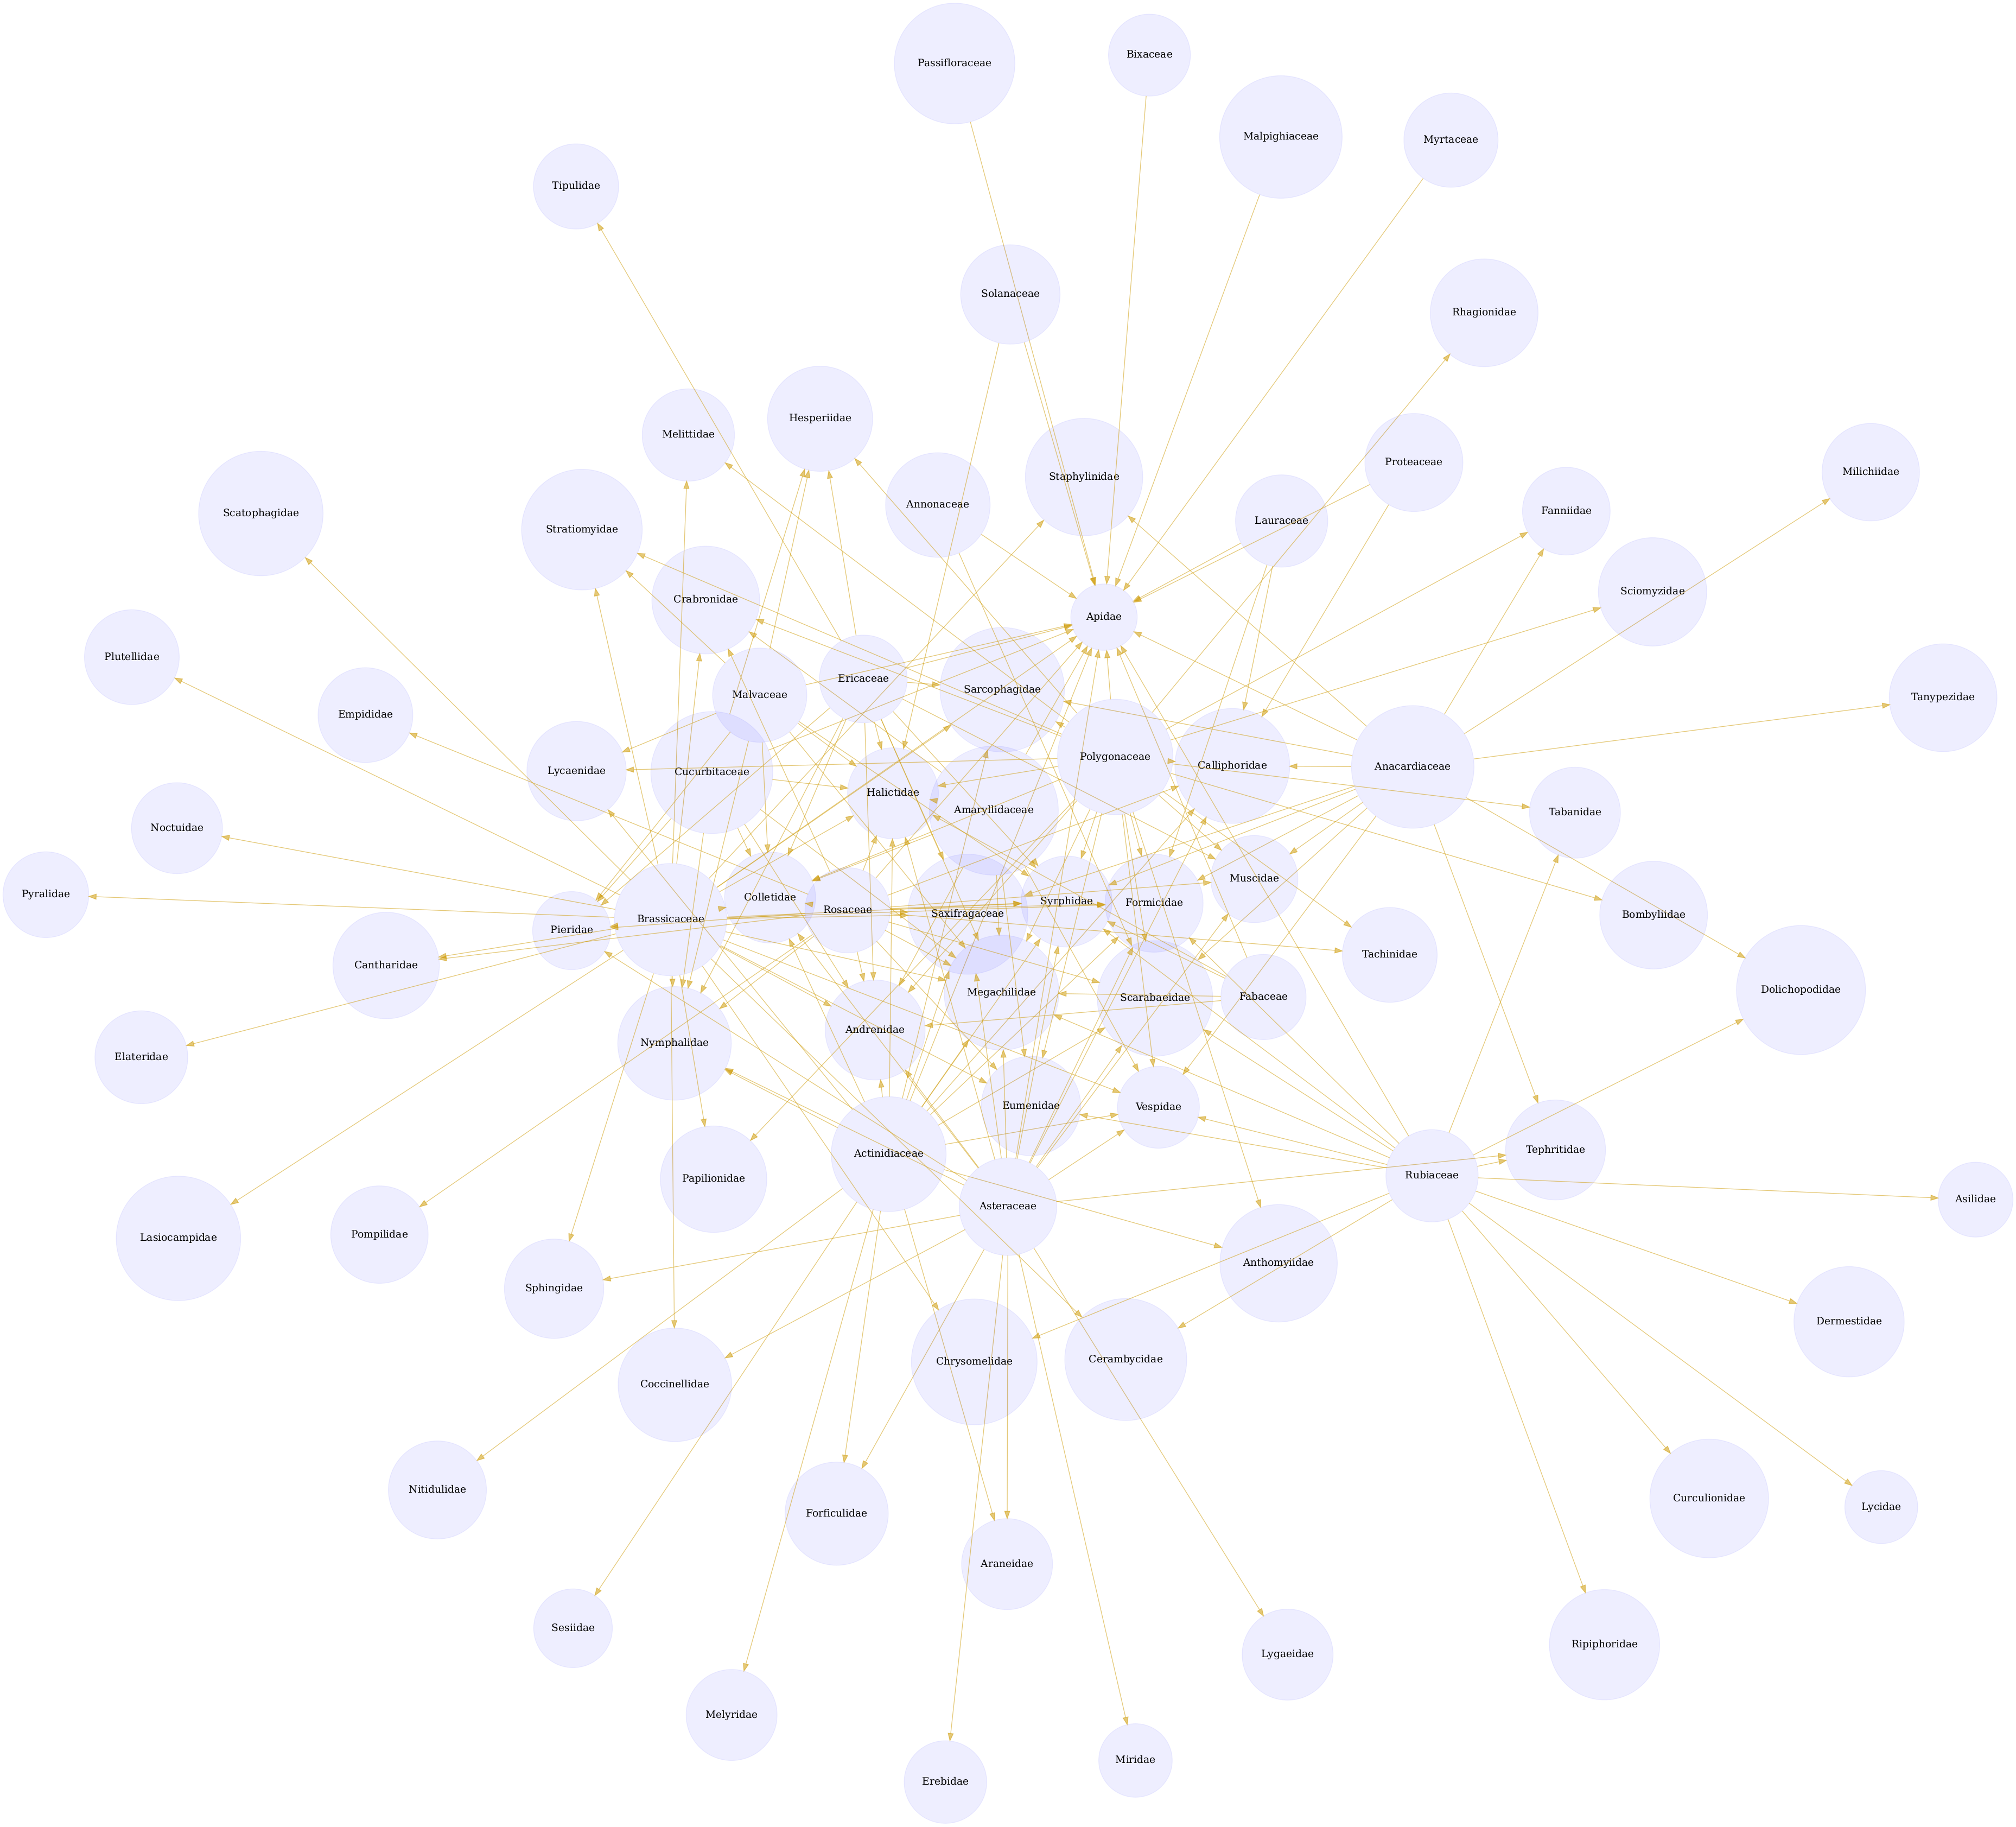
Interactions on the taxonomic family rank as interpreted by the Catalogue of Life. download svg
You can download the indexed dataset under review at indexed-interactions.csv.gz. A tab-separated file can be found at indexed-interactions.tsv.gz

Geospatial Distribution
If geospatial information was extracted from the dataset under review, the map below will show their distribution.
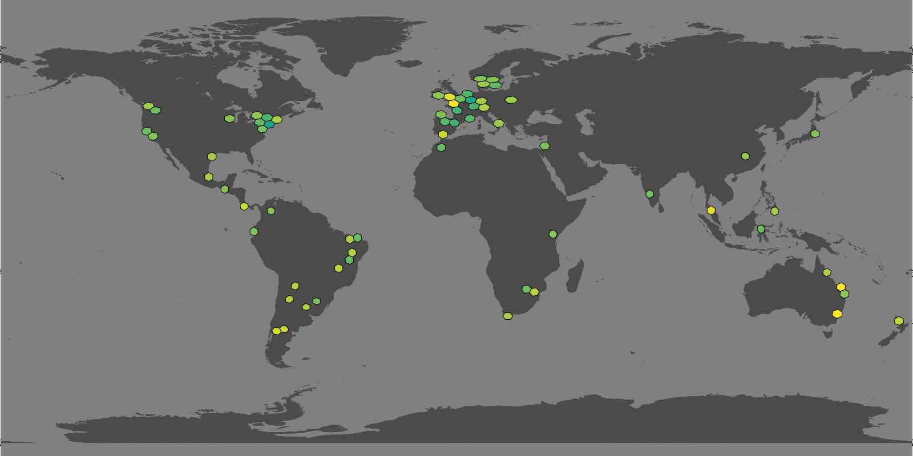
Hexagonal grid cells indicate that interactions claims are available for selected geospatial area: light yellow means relatively fewer claims, dark green relatively more claims.
Associated data can be found in the geopackage files at indexed-interactions.gpkg for point data and indexed-interactions-h3.gpkg for data clustered in geospatial h3 hexagonals.
Learn more about the structure of this download at GloBI website, by opening a GitHub issue, or by sending an email.
Another way to discover the dataset under review is by searching for it on the GloBI website.

Taxonomic Alignment
As part of the review, all names are aligned against various name catalogs (e.g., col, ncbi, discoverlife, gbif, itis, wfo, mdd, tpt, pbdb, and worms). These alignments can help review name usage or aid in selecting of a suitable taxonomic name resource.
Sample of Name Alignments
providedName | relationName | resolvedCatalogName | resolvedName
Bees than apidae | NONE | col | Bees than apidae
Abax parallelepipedus | HAS_ACCEPTED_NAME | col | Abax parallelepipedus
Abax parallelepipedus | SYNONYM_OF | col | Abax pilleri
Abeja abdomen naranja | NONE | col | Abeja abdomen naranja

Distribution of Taxonomic Ranks of Aligned Names by Catalog. Names that were not aligned with a catalog are counted as NAs. So, the total number of unaligned names for a catalog will be listed in their NA row.
resolvedCatalogName | resolvedRank | count
col | NA | 509
col | class | 1
col | family | 69
col | genus | 162
col | order | 13
col | species | 1111
col | subclass | 1
col | subfamily | 4
col | subgenus | 1
col | suborder | 1
col | subspecies | 11
col | superfamily | 5
col | tribe | 6
col | variety | 1
discoverlife | NA | 1132
discoverlife | species | 751
gbif | NA | 377
gbif | class | 2
gbif | family | 83
gbif | genus | 189
gbif | order | 13
gbif | species | 1221
gbif | subspecies | 11
gbif | variety | 1
itis | NA | 723
itis | class | 1
itis | family | 71
itis | genus | 139
itis | infraorder | 1
itis | order | 13
itis | species | 905
itis | subclass | 1
itis | subfamily | 8
itis | suborder | 7
itis | subspecies | 4
itis | superfamily | 5
itis | superorder | 1
itis | tribe | 4
mdd | NA | 1882
ncbi | NA | 583
ncbi | clade | 1
ncbi | class | 2
ncbi | cohort | 1
ncbi | family | 71
ncbi | genus | 162
ncbi | infraorder | 1
ncbi | order | 13
ncbi | species | 1017
ncbi | species group | 1
ncbi | subfamily | 9
ncbi | subgenus | 20
ncbi | suborder | 4
ncbi | subspecies | 5
ncbi | superfamily | 5
ncbi | tribe | 5
pbdb | NA | 1652
pbdb | class | 2
pbdb | family | 78
pbdb | genus | 86
pbdb | infraclass | 1
pbdb | order | 14
pbdb | species | 28
pbdb | subfamily | 5
pbdb | suborder | 7
pbdb | superfamily | 5
pbdb | tribe | 4
pbdb | unranked clade | 2
tpt | NA | 1881
tpt | species | 1
wfo | NA | 1829
wfo | genus | 9
wfo | species | 43
wfo | variety | 1
worms | NA | 1716
worms | class | 2
worms | family | 57
worms | genus | 52
worms | infraorder | 1
worms | order | 13
worms | species | 36
worms | suborder | 4
worms | superfamily | 1

Name relationship types per catalog. Name relationship type “NONE” means that a name was not recognized by the associated catalog. “SAME_AS” indicates either a “HAS_ACCEPTED_NAME” or “SYNONYM_OF” name relationship type. We recognize that “SYNONYM_OF” encompasses many types of nomenclatural synonymies (ICZN 1999) (e.g., junior synonym, senior synonyms).
resolvedCatalogName | relationName | count
col | NONE | 631
col | HAS_ACCEPTED_NAME | 2318
col | SYNONYM_OF | 348
discoverlife | NONE | 1969
discoverlife | HAS_ACCEPTED_NAME | 967
discoverlife | SYNONYM_OF | 322
discoverlife | HOMONYM_OF | 94
gbif | NONE | 474
gbif | HAS_ACCEPTED_NAME | 2790
gbif | SYNONYM_OF | 514
itis | NONE | 882
itis | HAS_ACCEPTED_NAME | 2069
itis | SYNONYM_OF | 117
mdd | NONE | 2998
ncbi | NONE | 681
ncbi | SAME_AS | 2423
ncbi | SYNONYM_OF | 87
ncbi | COMMON_NAME_OF | 1
pbdb | NONE | 2196
pbdb | HAS_ACCEPTED_NAME | 792
pbdb | SYNONYM_OF | 21
tpt | NONE | 2995
tpt | SYNONYM_OF | 3
wfo | NONE | 2879
wfo | HAS_ACCEPTED_NAME | 54
wfo | SYNONYM_OF | 69
wfo | HAS_UNCHECKED_NAME | 15
worms | NONE | 2376
worms | HAS_ACCEPTED_NAME | 597
worms | SYNONYM_OF | 39

List of Available Name Alignment Reports
catalog name | alignment results
col | associated names alignments report in gzipped html, csv, and tsv)
ncbi | associated names alignments report in gzipped html, csv, and tsv)
discoverlife | associated names alignments report in gzipped html, csv, and tsv)
gbif | associated names alignments report in gzipped html, csv, and tsv)
itis | associated names alignments report in gzipped html, csv, and tsv)
wfo | associated names alignments report in gzipped html, csv, and tsv)
mdd | associated names alignments report in gzipped html, csv, and tsv)
tpt | associated names alignments report in gzipped html, csv, and tsv)
pbdb | associated names alignments report in gzipped html, csv, and tsv)
worms | associated names alignments report in gzipped html, csv, and tsv)

Additional Reviews
Elton, Nomer, and other tools may have difficulties interpreting existing species interaction datasets. Or, they may misbehave, or otherwise show unexpected behavior. As part of the review process, detailed review notes are kept that document possibly misbehaving, or confused, review bots. An sample of review notes associated with this review can be found below.
First few lines in the review notes.
reviewDate | reviewCommentType | reviewComment
2026-02-02T10:47:33Z | note | invalid date string [2000-2001]
2026-02-02T10:47:33Z | note | invalid date string [2000-2001]
2026-02-02T10:47:33Z | note | invalid date string [2000-2001]
2026-02-02T10:47:33Z | note | invalid date string [2000-2001]
In addition, you can find the most frequently occurring notes in the table below.
Most frequently occurring review notes, if any.
reviewComment | count
found malformed doi [NA] | 11818
found invalid location: [invalid (latitude, longitude) = (NA,NA)] | 7373
target taxon name missing | 3448
found malformed doi [In preparation] | 1657
For additional information on review notes, please have a look at the first 500 Review Notes in html format or the download full gzipped csv or tsv archives.

GloBI Review Badge
As part of the review, a review badge is generated. This review badge can be included in webpages to indicate the review status of the dataset under review.
Picture of a GloBI Review Badge
Note that if the badge is green, no review notes were generated. If the badge is yellow, the review bots may need some help with interpreting the species interaction data.

GloBI Index Badge
If the dataset under review has been registered with GloBI, and has been succesfully indexed by GloBI, the GloBI Index Status Badge will turn green. This means that the dataset under review was indexed by GloBI and is available through GloBI services and derived data products.
Picture of a GloBI Index Badge
If you’d like to keep track of reviews or index status of the dataset under review, please visit GloBI’s dataset index for badge examples.

Discussion
This review and archive provides a means of creating citable versions of datasets that change frequently. This may be useful for dataset managers, including natural history collection data managers, as a backup archive of a shared Darwin Core archive. It also serves as a means of creating a trackable citation for the dataset in an automated way, while also including some information about the contents of the dataset.
This review aims to provide a perspective on the dataset to aid in understanding of species interaction claims discovered. However, it is important to note that this review does not assess the quality of the dataset. Instead, it serves as an indication of the open-ness and FAIRness (Wilkinson et al. 2016; Trekels et al. 2023) of the dataset: to perform this review, the data was likely openly available, Findable, Accessible, Interoperable and Reusable. The current Open-FAIR assessment is qualitative, and a more quantitative approach can be implemented with specified measurement units.
This report also showcases the reuse of machine-actionable (meta)data, something highly recommended by the FAIR Data Principles (Wilkinson et al. 2016). Making (meta)data machine-actionable enables more precise procesing by computers, enabling even naive review bots like Nomer and Elton to interpret the data effectively. This capability is crucial for not just automating the generation of reports, but also for facilitating seamless data exchanges, promoting interoperability.

Acknowledgements
We thank the many humans that created us and those who created and maintained the data, software and other intellectual resources that were used for producing this review. In addition, we are grateful for the natural resources providing the basis for these human and bot activities. Also, thanks to https://github.com/zygoballus for helping improve the layout of the review tables.

Author contributions
Nomer was responsible for name alignments. Elton carried out dataset extraction, and generated the review notes. Preston tracked, versioned, and packaged, the dataset under review.

References
Elliott, Michael, Jorrit Poelen, Icaro Alzuru, Emilio Berti, and partha04patel. 2025. “Bio-Guoda/Preston: 0.10.5.” Zenodo. https://doi.org/10.5281/zenodo.14662206.
ICZN. 1999. “International Code of Zoological Nomenclature.” The International Trust for Zoological Nomenclature, London, UK. https://www.iczn.org/the-code/the-code-online/.
Kuhn, Tobias, and Michel Dumontier. 2014. “Trusty URIs: Verifiable, Immutable, and Permanent Digital Artifacts for Linked Data.” In The Semantic Web: Trends and Challenges, edited by Valentina Presutti, Claudia d’Amato, Fabien Gandon, Mathieu d’Aquin, Steffen Staab, and Anna Tordai, 395–410. Cham: Springer International Publishing.
Kuhn, Tobias, Jorrit Poelen, and Katrin Leinweber. 2025. “Globalbioticinteractions/Elton: 0.15.1.” Zenodo. https://doi.org/10.5281/zenodo.14927734.
Poelen, Jorrit H. (ed.). 2024. “Nomer Corpus of Taxonomic Resources Hash://Sha256/ B60c0d25a16ae77b24305782017b1a270b79b5d1746f832650 F2027ba536e276 Hash://Md5/17f1363a277ee0e4ecaf1b91c665e47e.” Zenodo. https://doi.org/10.5281/zenodo.12695629.
Poelen, Jorrit H., James D. Simons, and Chris J. Mungall. 2014. “Global Biotic Interactions: An Open Infrastructure to Share and Analyze Species-Interaction Datasets.” Ecological Informatics 24 (November): 148–59. https://doi.org/10.1016/j.ecoinf.2014.08.005.
Poelen, Jorrit, Katja Seltmann, and Daniel Mietchen. 2024. “Globalbioticinteractions/Globinizer: 0.4.0.” Zenodo. https://doi.org/10.5281/zenodo.10647565.
Salim, José Augusto, and Jorrit Poelen. 2025. “Globalbioticinteractions/Nomer: 0.5.15.” Zenodo. https://doi.org/10.5281/zenodo.14893840.
Trekels, Maarten, Debora Pignatari Drucker, José Augusto Salim, Jeff Ollerton, Jorrit Poelen, Filipi Miranda Soares, Max Rünzel, Muo Kasina, Quentin Groom, and Mariano Devoto. 2023. “WorldFAIR Project (D10.1) Agriculture-related pollinator data standards use cases report.” Zenodo. https://doi.org/10.5281/zenodo.8176978.
Wilkinson, Mark D., Michel Dumontier, IJsbrand Jan Aalbersberg, Gabrielle Appleton, Myles Axton, Arie Baak, Niklas Blomberg, et al. 2016. “The FAIR Guiding Principles for Scientific Data Management and Stewardship.” Scientific Data 3 (1). https://doi.org/10.1038/sdata.2016.18.

Note that you have to first get the data (e.g., via elton pull ibartomeus/CropPol) before being able to generate reviews (e.g., elton review ibartomeus/CropPol), extract interaction claims (e.g., elton interactions ibartomeus/CropPol), or list taxonomic names (e.g., elton names ibartomeus/CropPol)
Disclaimer: The results in this review should be considered friendly, yet naive, notes from an unsophisticated robot. Please keep that in mind when considering the review results.
Up-to-date status of the GloBI Review Badge can be retrieved from the GloBI Review Depot
Up-to-date status of the GloBI Index Badge can be retrieved from GloBI’s API
At time of writing (2026-02-02) the version of the GloBI dataset index was available at https://globalbioticinteractions.org/datasets
According to http://opendefinition.org/: “Open data is data that can be freely used, re-used and redistributed by anyone - subject only, at most, to the requirement to attribute and sharealike.”

